Machine Learning (EECE 6822)



Project Final

Mohammad Saber
(MUID: 005852837)

Due date of submission: 04/30/2015

Expected Journal to submit:
- General Meeting of Power & Energy society
- International Symposium on Forecasting

Short-term Load Forecasting using Model Tree

Mohammad Saber
Dept. of Electrical and Computer Engineering
Marquette University
Milwaukee, WI, USA
mohammad.saber@marquette.edu
Richard J. Povinelli
Dept. of Electrical and Computer Engineering
Marquette University
Milwaukee, WI, USA
richard.povinelli@marquette.edu

Abstract— A regression tree is a very simple and effective way to predict the future based on historical data. Model tree [1] is the improved version of original regression tree algorithm [2] which can handle missing data and continuous attribute. In this paper, model tree (R5P) technique has been applied as a forecasting tool to generate seven days hourly and daily electric load forecast using real data of an American power distribution company. The forecasting result found from R5P has been compared with most popular forecasting technique linear regression (LR).
Index Terms—Load forecasting, Model tree.

Introduction
Load forecasting is important for power generation and distribution companies to make valuable decisions ahead of time that can ultimately maximize their business profit. It also helps the local power distribution companies to increase their quality of service for customers by providing uninterrupted flow with the required voltage level [4]. Based on the forecast time horizon there are three categories of load forecasting. The forecasting range of one hour to one week is considered as short-term load forecasting whereas one week to one year duration of forecast and more than one year of forecast are called as mid-term and long-term load forecast respectively [4]. If the forecasting duration is less than one hour then it is called very short-term load forecasting [5]. Different kind of historical data are helpful for different categories of forecast. For short-term load forecasting, weather conditions (temperature, wind speed, cloud cover, precipitation) and calendar (day of the week, weekend, weekdays) are considered as most useful factors. Forecasting result of electric load heavily depends on whether condition and weather is a non-linear chaotic system. Thus it’s very difficult to accurately predict weather for long duration, which implies that mid-term and long-term load forecast based on long-term weather forecasting data is more vulnerable than short-term load forecasting. For the mid-term and long-term load forecasting, historical data of demand and climate (humidity, temperature, humidity temperature index), economic report (economic activities of country, economic variables which effects energy demand), number of users, their purchasing capacity and their lifestyle [5]. Considering difficulty and uncertainty level of data for long-term load forecast, short-term load forecasting is more useful and popular. Thus most of the literature in load forecasting research area focuses on short-term load forecasting.
Many techniques have been used for load forecasting. Linear regression model [6, 7] and artificial neural networks [8, 9] are the most popular techniques. Other techniques like support vector machine [4, 10], Gray forecasting model [10], Fuzzy inference model [12], Decision tree [11], ANFIS [4] (mixture of artificial neural network and fuzzy logic) are also used for load forecasting. Linear regression is the easiest method to obtain a reasonable forecast accuracy. As mentioned earlier weather data is non-linear, thus the accuracy of linear regression forecasting model based on non-linear data is lower than other artificial neural network on testing dataset. But in practice we can observe that artificial neural network can’t predict well in case of sharp changes of weather. Thus linear regression is still most popular method for load forecasting. Regression tree works better for non-linear data. The improved version of regression tree algorithm 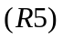 [3] uses linear regression on leave nodes of regression tree rather than using simple average which gives better result than linear regression model on non-linear dataset. Wang et al 1997, found R5 difficult to implement. Thus they came up with a slightly different technique 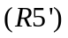 which is easy to implement and perform better than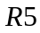. The implementation of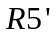 algorithm is available in machine learning toolbox WEKA [13] named R5P.
In this paper, original electricity demand data of an American power distribution company has been used to forecast hourly and daily electricity demand for one week in advance. The result found from R5P has been compared with linear regression (LR) model in WEKA. Effect of missing values on LR and R5P is also discussed based on forecasting result.
Model tree (R5P) algorithm is discussed in section II. Data processing and different attributes used to build forecasting are discussed in section III. Section IV contains experimental results with discussion. Section V concludes the paper with some future scope of works.

Model Tree (R5P)
In first stage of building a model tree (R5P), a decision-tree algorithm is used with different splitting criteria. Instead of choosing the attribute which maximizes the information gain, the attribute which minimizes the intra-subset variation is selected for building a R5P tree. The formula used to find splitting attribute is called standard deviation reduction (SDR).
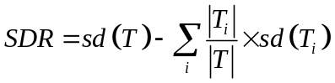
Where is the set of all examples reached in a particular node and , i = 1,2, … are the sets of the sub-examples generated from the split of that node. Splitting stops when the calculated SDR value is very insignificant or only a few instances left. This algorithm works for missing values also. To take account of missing values, the above mentioned formula for finding SDR is modified to
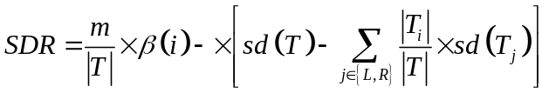
Where, m is the number of examples without missing values for that attribute, and T is the number of examples which reach this node. β(i) is the correction factor which is 1 for binary split. The correction factor decays exponentially with the increase of number of split points. T_{L} and T_{R} results from binary split of T on any attribute.
After building the decision tree, next step is to prune it back. Mean absolute error is used as a measure to decide how far the tree would be pruned. While growing the regression tree, calculation of the absolute mean error for every node are done by the algorithm. But the calculated error from training examples will definitely underestimate the error of unseen examples. Thus to compensate it, calculated mean absolute error of node will be multiplied by 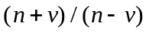, where n is the number of examples reaches in a particular node and v is the number of parameters in the model that represents the class value.
M5P computes a linear model for each internal node of the unpruned tree. Minimum number of attributes are used for each linear regression model. Attributes are dropped one at a time and checked whether the new model is better than old or not using above mention error calculation technique. Finally when every node has their linear model ready, then pruning start from leaf node. If the calculated error of a parent node is less than the current node, then one level of pruning will be done. In this way, pruning will continue until reduction of error is possible. When there will be no improvement from pruning, the algorithm will stop pruning operation.
Pruning process can create sharp discontinuity between two adjacent nodes which can effect forecasting performance. A smoothing technique is used to solve this problem. The formula used for smoothing is
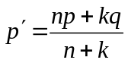,
Where p’ is the prediction passed up to the next higher node, p is the prediction passed to the current node from below, n is the number of training examples that reach the node below, k is a constant (default value 15), and q is the value predicted by the model for current node. The experimental result of [1] shows that the smoothing improves forecasting result comparing with unsmoothing technique.

Data processing
Original electric demand and weather data collected from an American power supply company is used to test the performance of R5P. Primarily there are five attributes (date, temperature, wind speed, dew point and demand) in the dataset. Cooling degree day (CDD) and heating degree day (HDD) are also considered as important attribute for energy forecast. These two attributes can be calculated from the primary attribute temperature using following formulas [14].
HDD_{k} = max {0, T_{ref}-T_{k}}
CDD_{k} = max {T_{k}-T_{ref} , 0}
Here k is called the reference temperature. In this paper reference temperature for calculating HDD and CDD are considered 55 and 65 respectively. Five years of hourly data are used for the experiment. 35060 instances (4 years of hourly data) are used for training purpose and 8783 examples (1 year of hourly data) are used for testing. There are total 197 missing values in this dataset.

EXPERIMENTAL RESULTS
The famous data mining software WEKA [13] is used for the experiment. In this experiment, 33 lag terms (1-24, 36, 48, 60, 72, 84, 96, 120, 144, and 168) are used to create forecasting model. Weekend and weekdays has different characteristics for load demand. Usually, industry customers require more electricity in weekdays than weekends. On the other hand residential customers use more electricity in weekends than weekdays. Day of the week also shows unique pattern in electricity load forecast. Thus these two attributes are also include in the final model to improve forecasting accuracy. WEKA generates a tree with 436 leaves after feeding with above mentioned setup which is quite reasonable considering huge number of attributes and examples. It takes around 3 seconds to build the R5P tree model which indicates that the algorithm is fast enough to compare the timing complexity of linear regression model. Other forecasting models like artificial neural networks (ANN) and support vector machines (SVM) take around 45 and 1000 times more time respectively than R5P on same dataset and setup of WEKA. R5P takes double time than linear regression on same examples and attribute settings in WEKA. All the experiments have been done in Windows 7 machine with Intel core i5 CPU@ 3.4 GHz, and 8GB of RAM. Timing comparison of LR, ANN, SVM, and R5P are done using smaller dataset (1 year of hourly data). SVM and ANN couldn’t finish building forecasting model in WEKA for larger datasets (3 or more years of hourly data) due to out of memory.
- Pruned R5P in WEKA (every leaf node set to at least 4000 examples)
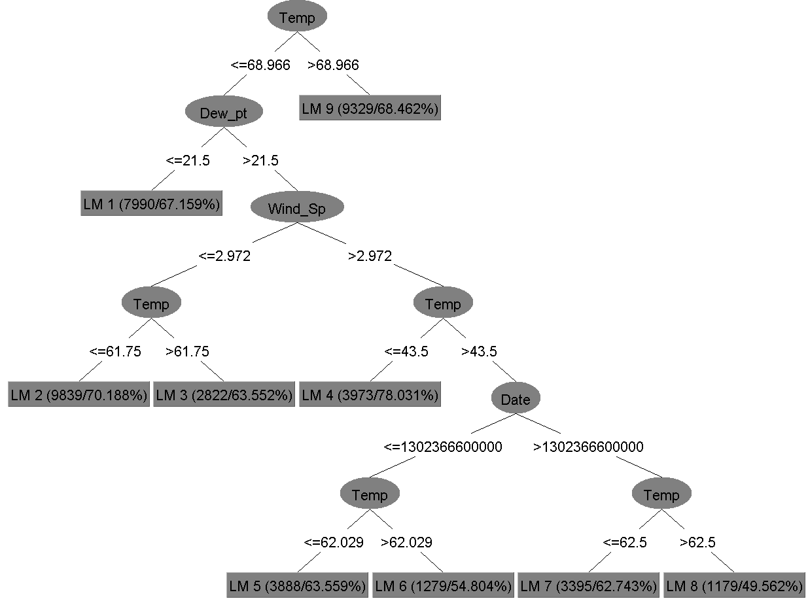
Fig. 1 shows the R5P tree generated by WEKA. As mentioned above, the original tree contains 436 leaf nodes, thus it is impossible to make it readable and display in this paper. Thus the parameter of pruning algorithm set to at least 4000 examples in each leaf node from default 4 to create a smaller tree for visualization of first few levels of the original tree.
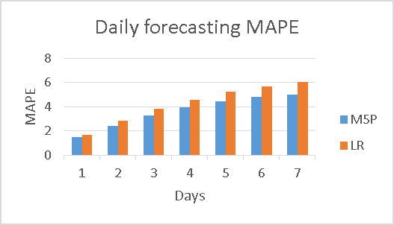

- Daily forecasting MAPE of R5P and LR
Fig. 2 shows the mean absolute percentage error (MAPE) of daily forecast from R5P and LR model in WEKA. Forecast is done for next seven days with hourly moving window for 1 year period. To calculate the accuracy of forecast following formula is used.

Here, n is the number of testing examples, A_{t} is the actual demand for time t and F_{t} is the forecasted demand for time t. Using the same model hourly forecast of 1 week (168 hours) is tried. Table. 1 shows the MAPE comparison of LR and R5P model for 168 hours of forecast.
- Hourly forecasting mape of LR & R5P model
MAPE for LR and R5P model
Hour | LR | R5P | Hour | LR | R5P | Hour | LR | M5P
1 | 1.4 | 1.6 | 57 | 7.4 | 7.4 | 113 | 8.2 | 8
2 | 2.3 | 2.5 | 58 | 7.4 | 7.4 | 114 | 8.2 | 8
3 | 2.9 | 3.2 | 59 | 7.4 | 7.4 | 115 | 8.2 | 8
4 | 3.4 | 3.7 | 60 | 7.4 | 7.4 | 116 | 8.2 | 8
5 | 3.8 | 4.1 | 61 | 7.4 | 7.4 | 117 | 8.2 | 8
6 | 4.1 | 4.3 | 62 | 7.4 | 7.4 | 118 | 8.3 | 8
7 | 4.3 | 4.5 | 63 | 7.4 | 7.4 | 119 | 8.3 | 8
8 | 4.5 | 4.6 | 64 | 7.5 | 7.4 | 120 | 8.3 | 8
9 | 4.6 | 4.7 | 65 | 7.5 | 7.4 | 121 | 8.4 | 8
10 | 4.7 | 4.8 | 66 | 7.5 | 7.4 | 122 | 8.4 | 8.1
11 | 4.7 | 4.8 | 67 | 7.5 | 7.4 | 123 | 8.5 | 8.1
12 | 4.8 | 4.9 | 68 | 7.5 | 7.4 | 124 | 8.5 | 8.1
13 | 4.8 | 4.9 | 69 | 7.5 | 7.4 | 125 | 8.6 | 8.2
14 | 4.9 | 4.9 | 70 | 7.5 | 7.4 | 126 | 8.6 | 8.2
15 | 5 | 5 | 71 | 7.5 | 7.4 | 127 | 8.6 | 8.2
16 | 5 | 5 | 72 | 7.5 | 7.4 | 128 | 8.6 | 8.2
17 | 5.1 | 5.1 | 73 | 7.5 | 7.4 | 129 | 8.6 | 8.2
18 | 5.1 | 5.1 | 74 | 7.6 | 7.5 | 130 | 8.5 | 8.2
19 | 5.1 | 5.1 | 75 | 7.7 | 7.6 | 131 | 8.5 | 8.2
20 | 5.1 | 5.1 | 76 | 7.7 | 7.6 | 132 | 8.5 | 8.2
21 | 5.1 | 5.1 | 77 | 7.8 | 7.7 | 133 | 8.5 | 8.2
22 | 5.1 | 5.1 | 78 | 7.8 | 7.7 | 134 | 8.5 | 8.2
23 | 5.1 | 5.1 | 79 | 7.8 | 7.7 | 135 | 8.5 | 8.2
24 | 5.2 | 5.1 | 80 | 7.8 | 7.7 | 136 | 8.5 | 8.2
25 | 5.3 | 5.3 | 81 | 7.8 | 7.7 | 137 | 8.6 | 8.2
26 | 5.5 | 5.7 | 82 | 7.8 | 7.7 | 138 | 8.6 | 8.2
27 | 5.8 | 6 | 83 | 7.8 | 7.7 | 139 | 8.6 | 8.2
28 | 6 | 6.2 | 84 | 7.8 | 7.7 | 140 | 8.6 | 8.2
29 | 6.1 | 6.3 | 85 | 7.8 | 7.7 | 141 | 8.7 | 8.3
30 | 6.3 | 6.5 | 86 | 7.8 | 7.7 | 142 | 8.7 | 8.3
31 | 6.4 | 6.5 | 87 | 7.8 | 7.7 | 143 | 8.6 | 8.3
32 | 6.4 | 6.6 | 88 | 7.8 | 7.7 | 144 | 8.7 | 8.3
33 | 6.5 | 6.6 | 89 | 7.8 | 7.7 | 145 | 8.7 | 8.3
34 | 6.5 | 6.7 | 90 | 7.8 | 7.7 | 146 | 8.8 | 8.3
35 | 6.5 | 6.7 | 91 | 7.9 | 7.7 | 147 | 8.8 | 8.4
36 | 6.6 | 6.7 | 92 | 7.9 | 7.7 | 148 | 8.9 | 8.4
37 | 6.6 | 6.7 | 93 | 7.9 | 7.7 | 149 | 8.9 | 8.4
38 | 6.6 | 6.8 | 94 | 7.9 | 7.7 | 150 | 8.9 | 8.4
39 | 6.7 | 6.8 | 95 | 7.9 | 7.7 | 151 | 9 | 8.5
40 | 6.7 | 6.8 | 96 | 7.9 | 7.7 | 152 | 8.9 | 8.5
41 | 6.7 | 6.8 | 97 | 8 | 7.8 | 153 | 8.9 | 8.5
42 | 6.7 | 6.8 | 98 | 8 | 7.8 | 154 | 8.9 | 8.5
43 | 6.7 | 6.8 | 99 | 8.1 | 7.9 | 155 | 8.9 | 8.5
44 | 6.8 | 6.8 | 100 | 8.2 | 7.9 | 156 | 8.9 | 8.5
45 | 6.8 | 6.8 | 101 | 8.2 | 8 | 157 | 8.9 | 8.5
46 | 6.8 | 6.8 | 102 | 8.2 | 8 | 158 | 8.9 | 8.5
47 | 6.8 | 6.8 | 103 | 8.3 | 8 | 159 | 8.9 | 8.5
48 | 6.8 | 6.8 | 104 | 8.2 | 8 | 160 | 8.9 | 8.5
49 | 6.9 | 6.9 | 105 | 8.2 | 8 | 161 | 8.9 | 8.5
50 | 7 | 7 | 106 | 8.2 | 8 | 162 | 8.9 | 8.5
51 | 7.1 | 7.1 | 107 | 8.2 | 8 | 163 | 8.9 | 8.5
52 | 7.1 | 7.2 | 108 | 8.2 | 8 | 164 | 9 | 8.5
53 | 7.2 | 7.3 | 109 | 8.2 | 8 | 165 | 9 | 8.5
54 | 7.3 | 7.3 | 110 | 8.2 | 8 | 166 | 9 | 8.5
55 | 7.4 | 7.3 | 111 | 8.2 | 8 | 167 | 9 | 8.5
56 | 7.4 | 7.4 | 112 | 8.2 | 8 | 168 | 9 | 8.5
From table 1, it is observed that the error of R5P model is less than or equal to the error of LR model for first 63 hours of forecasts and then LR model performed better than R5P. The selected training and testing dataset contain lots of consecutive missing values which may affect the accuracy of forecasting especially when the step size for forecasting increases. Iterative forecasting models are used in this experiment which propagate error in every step could be another reason for increasing MAPE with the increase of step size of forecasting.

Conclusion
In this paper, R5P tree is used to generate hourly and daily forecast for 7 days in advance. Real electricity demand data collected from an American power distribution company is used for all experiments done in this paper. Finally the short-term load forecasting performance of R5P is compared with LR model.
For future work, direct method can be tried. In iterative method only one model is used to generate forecast for 168 hours. In this way the error propagates in every step of forecast. 168 different models can be created and each model can be used for one step forecast. Thus, 168 hours forecast can be generated from 168 models. Different splitting criteria can be used to grow R5P tree which may improve forecast accuracy. Holidays are not considered in this experiment. But electric demand of Christmas time will definitely different than other time of the year. Industries are closed in Christmas, thus we can expect less demand in industrial areas than other time. On the other hand residential customers use more lighting to do party in Christmas time, thus it is expected to have more demand in residential areas. Thus the characteristic of electricity demand is different in Christmas holidays. The effect of Thanksgiving and Easter holidays on electricity demand can be investigated whether there are different load pattern for those holidays also.

References
- Y. Wang and I.H. Witten, “Induction of model trees for predicting continuous classes”, In Proc. European Conference on Machine Learning Poster Papers, Prague, Czech Republic, 1997, pp. 128-137.
- L. Breiman, J.H. Friedman, R.A. Olshen, and C.J. Stone, “Classification and Regression Trees”, Wadsworth, Belmont CA, 1984.
- J. R. Quinlan, “Induction of Decision Trees”, Machine Learning 1, 1986, pp. 81-106.
- A. Escobar M and L.P. Perez., “Application of Support Vector Machines and ANFIS to the Short-term Load Forecasting”, Transmission and Distribution Conference and Exposition: Latin America, IEEE, 2008, pp. 1-5.
- Pang Qingle and Zhang Min, “Very Short-Term Load Forecasting Based on Neural Network and Rough Set”, International Conference on Intelligent Computation Technology and Automation, IEEE, 2010, pp. 1132-1135.
- Tao Hong, and Jason Wilson, “Long Term Probabilistic Load Forecasting and Normalization With Hourly Information”, IEEE transaction of smart grid, vol. 5, no. 1, 2014, pp. 456-462.
- Richard Cebula and Nate Herder, “An Empirical Analysis of Determinants of Commercial and industrial Electricity Consumption”, MPRA, paper no. 56763, 2014.
- Du Xin-hui, Tian Feng, and Tan Shao-qiong, “Study of Power System Short-term Load Forecast Based on Artificial Neural Network and Genetic Algorithm”, 2010 International Conference on Computational Aspects of Social Networks, IEEE, 2010, pp. 725 – 728.
- Xiaorong Sun, peter B. Luh, Laurent D. Michel, Stephen Corbo, Kwok W. Cheung, and Wei Guan, “An Efficient Approach for Short-Term Substation Load Forecasting”, Power and Energy Society General Meeting, IEEE, 2013, pp. 1-5.
- Xin Jin, Jie Wu, Yao Dong, Dezhong Chi, “Application of A Hybrid Model to Short-Term Load Forecasting”, International Conference of Information Science and Management Engineering, IEEE, 2010, pp. 492 – 497.
- Qia Ding, “Long-Term Load Forecast Using Decision Tree Method”, Power Systems Conference and Expostion, IEEE, 2006, pp. 1541-1543.
- Saleh Ahmadi, Hassan Bevrani, and Hannah Jannaty, “A fuzzy inference model for short-term load forecasting”, Second Iranian Conference on Renewable Energy and Distributed Generation, IEEE, 2012, pp. 39-44.
- Mark Hall, Eibe Frank, Geoffrey Holmes, Bernhard Pfahringer, Peter Reutemann, and Ian H. Witten, “The WEKA Data Mining Software: An Update; SIGKDD Explorations”, Volume 11, Issue 1, 2009.
- Steven R. Vitullo, Ronald H. Brown, George F. Corliss and Brian M. Marx, “Mathematical Models for Natural Gas Forecasting”, Canadian applied mathematics quarterly, vol. 17, No. 4, 2009, pp. 807-827.

